Preorders now available for the below LIFEwear items.
Order by Jan 22, 2024
PICS Hoodie: Walk by Faith or Soli Deo Gloria - Youth and Adult sizes available
PICS T-Shirt: Walk by Faith or Soli Deo Gloria – Youth and Adult sizes available
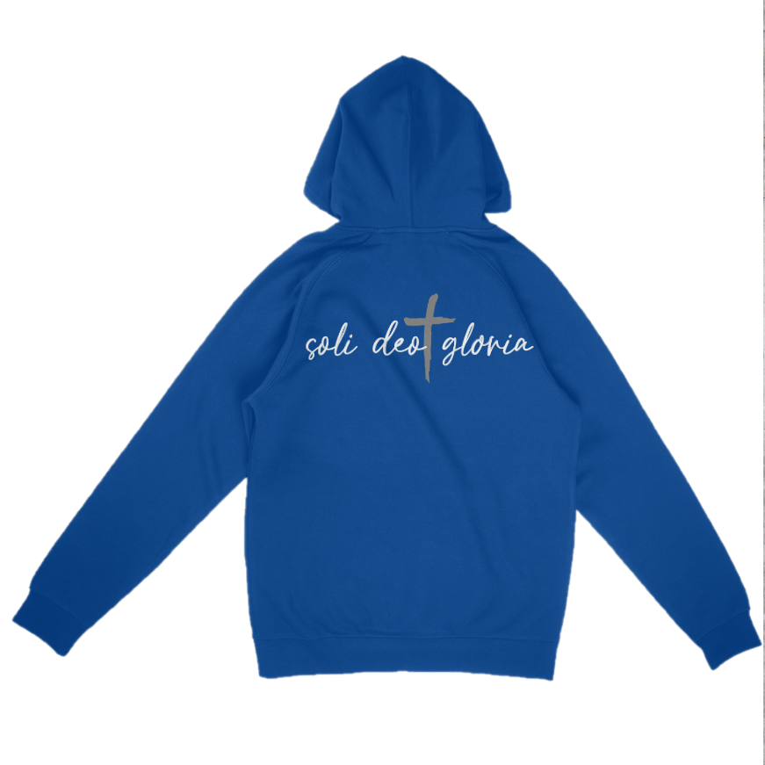
See positioning of logos below. T-shirts will have the same layout.
Please note colors may not be exactly as shown.




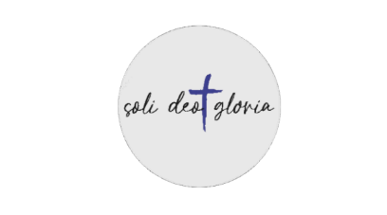
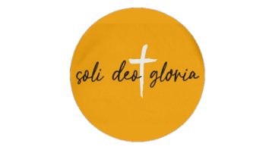
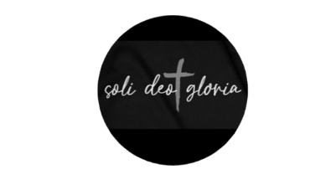
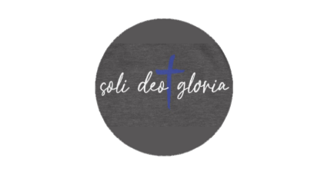

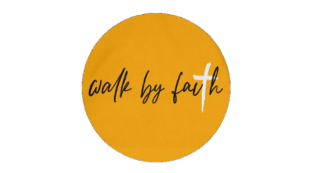
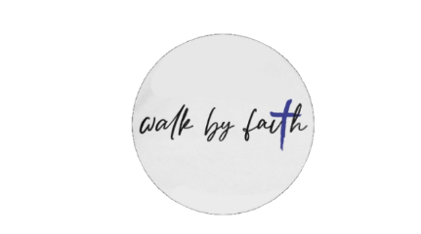
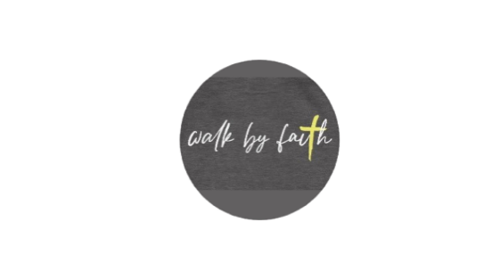
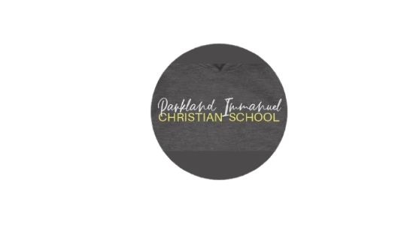




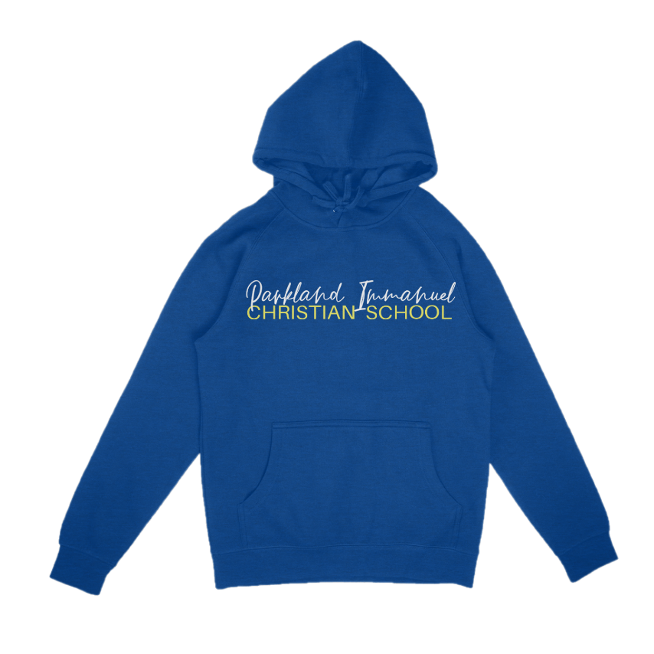
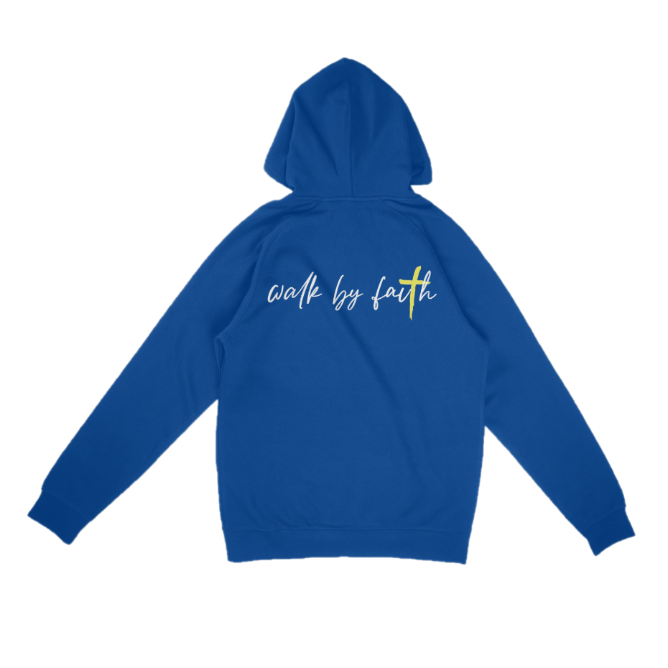

Walk by Faith
Front: Parkland Immanuel Christian School Back: Walk by Faith
Sizing Options - Adult: S-XXXL Youth: S-XL

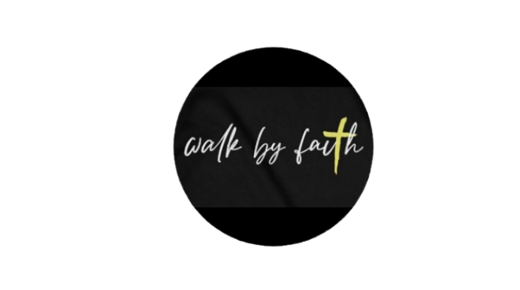
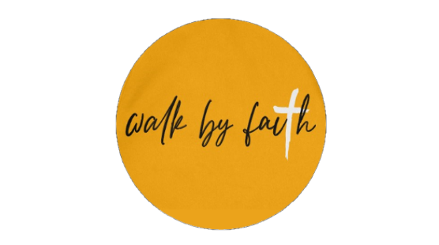


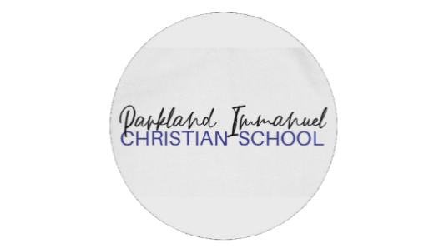
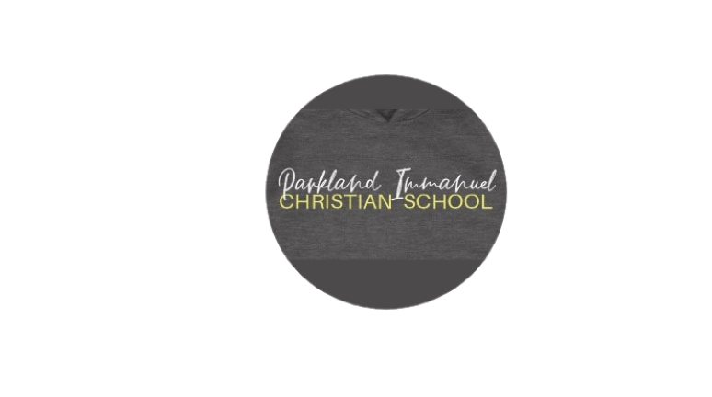
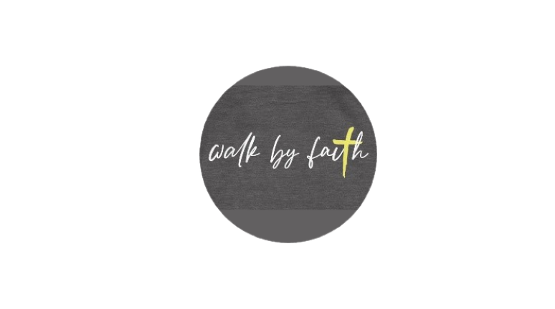
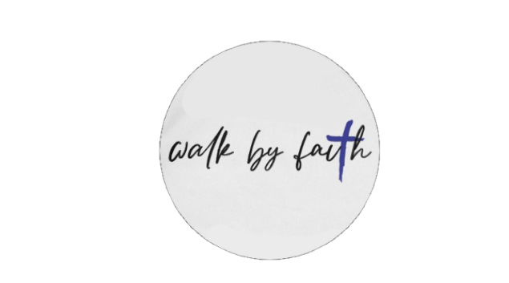
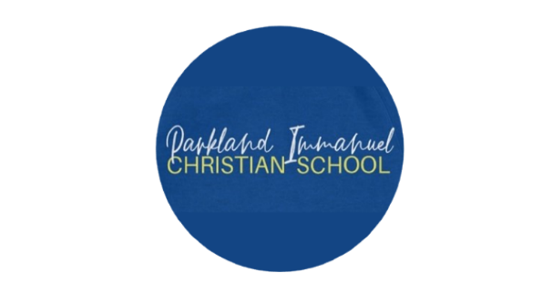
Item | QTY | Size | Total
Adult Hoodies - $50
Blue with White/Yellow |  | S M L XL XXL XXXL
Black with White/Yellow |  | S M L XL XXL XXXL
Gold with White/Black |  | S M L XL XXL XXXL
White with Blue/Black |  | S M L XL XXL XXXL
Charcoal with White/Yellow |  | S M L XL XXL XXXL
Youth Hoodies - $45
Blue with White/Yellow |  | S M L XL
Black with White/Yellow |  | S M L XL
Gold with White/Black |  | S M L XL
White with Blue/Black |  | S M L XL
Charcoal with White/Yellow |  | S M L XL
Adult T-Shirt - $25
Blue with White/Yellow |  | S M L XL XXL XXXL
Black with White/Yellow |  | S M L XL XXL XXXL
Gold with White/Black |  | S M L XL XXL XXXL
White with Blue/Black |  | S M L XL XXL XXXL
Charcoal with White/Yellow |  | S M L XL XXL XXXL
Youth T-Shirt - $18
Blue with White/Yellow |  | S M L XL
Black with White/Yellow |  | S M L XL
Gold with White/Black |  | S M L XL
White with Blue/Black |  | S M L XL
Charcoal with White/Yellow |  | S M L XL
Subtotal
Soli Deo Gloria
Front: Parkland Immanuel Christian School/PICS Back: Soli Deo Gloria
Sizing Options - Adult: S-XXXL Youth: S-XL





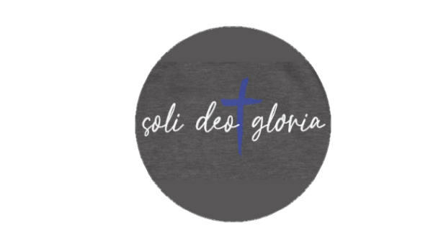
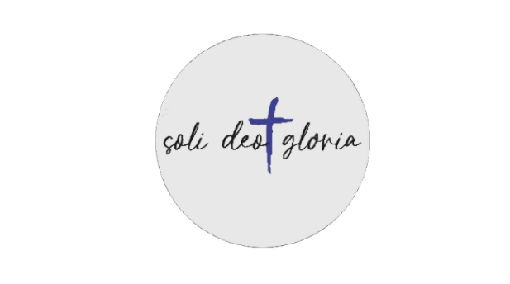
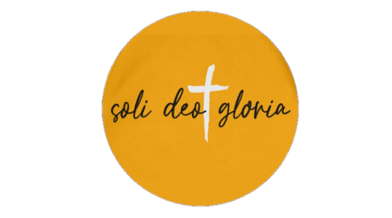
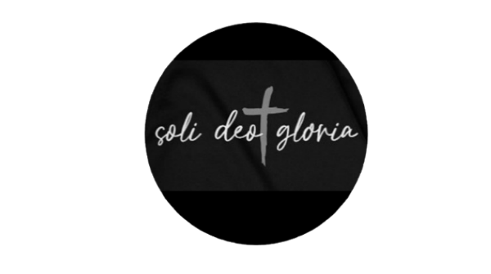
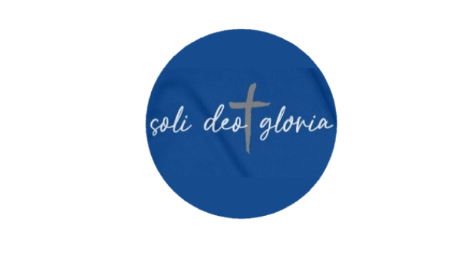
Item | QTY | Size | Total
Adult Hoodies - $50
Blue with White/Grey |  | S M L XL XXL XXXL
Black with White/Grey |  | S M L XL XXL XXXL
Gold with White/Black |  | S M L XL XXL XXXL
White with Blue/Black |  | S M L XL XXL XXXL
Charcoal with White/Blue |  | S M L XL XXL XXXL
Youth Hoodies - $45
Blue with White/Grey |  | S M L XL
Black with White/Grey |  | S M L XL
Gold with White/Black |  | S M L XL
White with Blue/Black |  | S M L XL
Charcoal with White/Blue |  | S M L XL
Adult T-Shirt - $25
Blue with White/Grey |  | S M L XL XXL XXXL
Black with White/Grey |  | S M L XL XXL XXXL
Gold with White/Black |  | S M L XL XXL XXXL
White with Blue/Black |  | S M L XL XXL XXXL
Charcoal with White/Blue |  | S M L XL XXL XXXL
Youth T-Shirt - $18
Blue with White/Grey |  | S M L XL
Black with White/Grey |  | S M L XL
Gold with White/Black |  | S M L XL
White with Blue/Black |  | S M L XL
Charcoal with White/Blue |  | S M L XL
Subtotal

