**Parkland Immanuel Christian School**

**2023-2024 Education Plan**

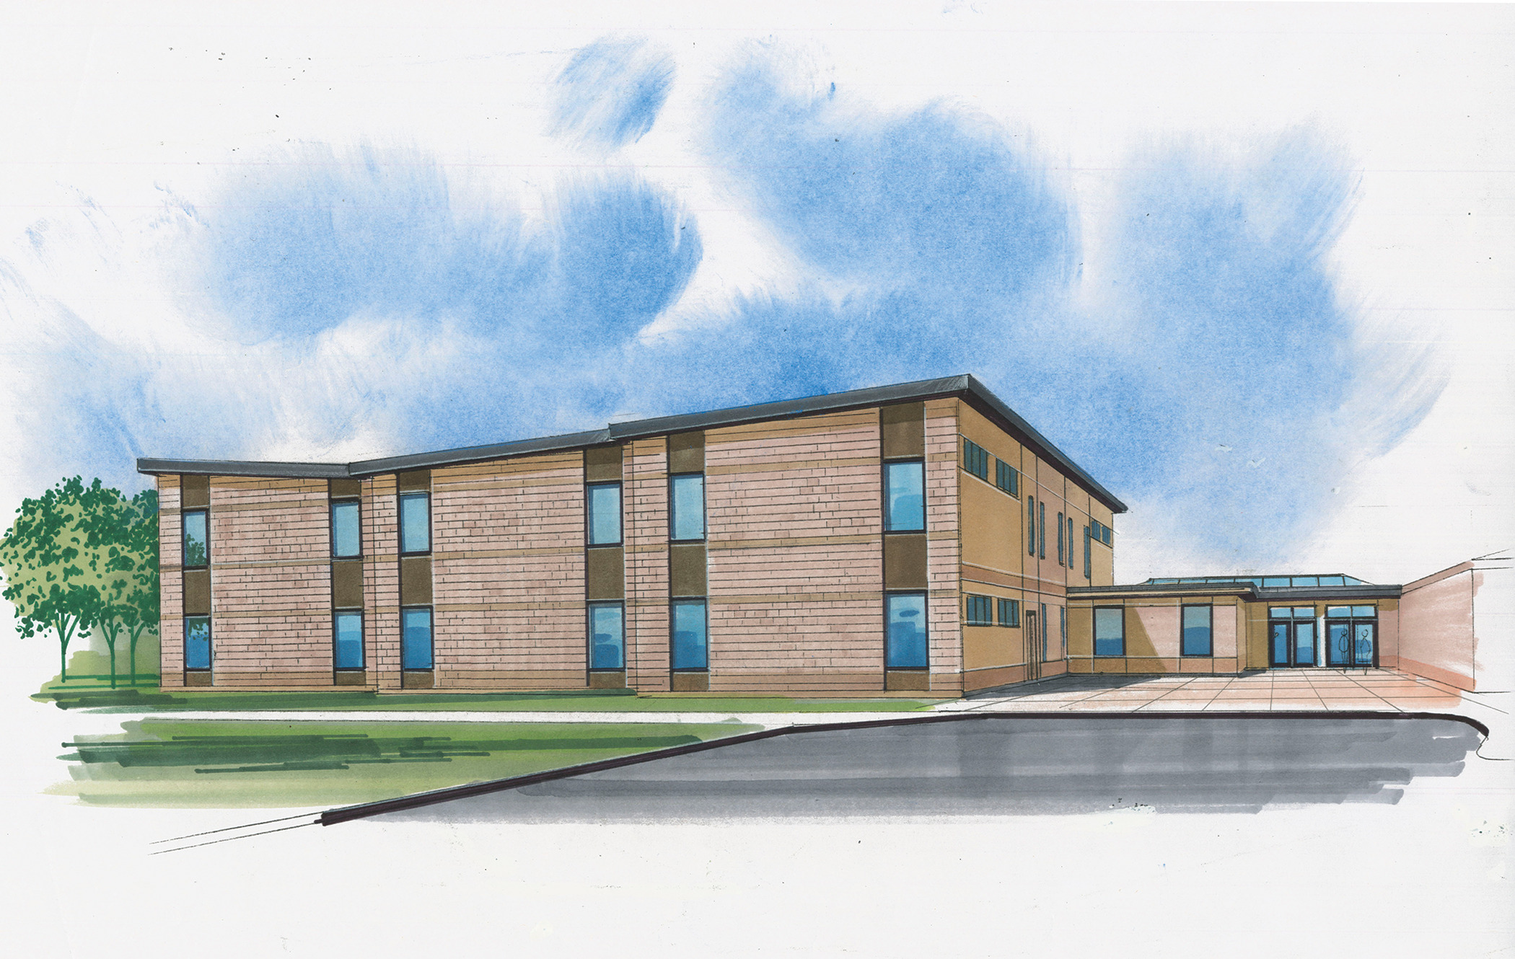

**School Profile**

In 1977, a small community of enthusiastic parents planned, built and opened a little school outside of Edmonton proper in the County of Parkland. These parents and their supporting church community were committed to quality education that would prepare their children to be ambassadors for Christ and energetic contributors to society.

Much has changed over the years at Parkland Immanuel Christian School (PICS): the school has grown from a little school with a few teachers and a few dozen students to a vibrant learning institute with 470 students and 50 teachers and educational assistants. PICS has blossomed from offering foundational core subjects to providing a learning environment offering a wide variety of curricular and extra-curricular opportunities for students.

Yet behind this growth and diversity, crucial anchors have kept the school community firmly tied to its roots: the ongoing blessings of God; the robust energy of our community volunteers and supporters; and a strong partnership with Alberta Education.

Parkland Immanuel Christian School is continuing the work of providing Christian education to children of Reformed believers that first began when PICS opened its doors in 1977. As part of this work, the School Board, administration, and staff continue to work with parents and students to implement strategies that support our mission, mandate, and vision.

**Mission**

The purpose of Parkland Immanuel Christian School is to provide parents a Christian learning environment for educating their children. We strive to develop the students’ talents so that they acquire the knowledge, skills and attitudes needed for a life of responsible Christian stewardship. The school will also provide an atmosphere where students can grow in maturity in their relationship with one another.

**Mandate**

Parents are primarily responsible for the education of their children. In order for education to be most effective, there should be uniformity of purpose and direction between home, school, and church. To achieve this, parents belonging to Canadian Reformed Churches of Edmonton have established a school society and elected a parental board to operate and maintain Parkland Immanuel Christian School. It is the mandate of this board to hire suitable staff to carry out the daily instruction in the school in accordance with the directives of the society and subject to Holy Scriptures, as summarized in the Belgic Confession, Heidelberg Catechism, and Canons of Dort.

**Vision**

Parkland Immanuel Christian School is a Reformed covenantal school rooted in God's Word and the confessions of the Canadian Reformed Church. Our covenant community will have such harmony and support from its parents, staff and students that it forms a powerful voice glorifying God and demonstrating hope in a broken world. We will continually strive to express our understanding of God's gift of grace and the value of providing consistent instruction between school, church and home.

*Enthusiastic Learning*

Parkland Immanuel Christian School will seek to create an environment where staff and students are inspired and challenged to use their God given talents as they joyfully teach and learn about our God and the world from a covenantal perspective. They will engage in activities that foster a love for learning, develop the ability to think critically about the world around them, and promote strong leadership skills.

*Caring People*

Parkland Immanuel Christian School will attract, develop and retain individuals whose words and actions glorify God and model Christ's love and purpose in their own spiritual and academic growth. They will strive for excellence in leadership and communication with peers, parents and the community.

*Nurturing Community*

Parkland Immanuel Christian School will be prayerfully supported by a welcoming multi-generational community that is actively involved through volunteering, membership in committees or boards, and by participation in regular school activities. It will seek to build strong partnerships with all members of the Reformed community and promote a sense of belonging, ownership and pride.

**Highlights of 2022-2023 School Year**

The 2022-2023 year saw a return to normal operations after having endured three school years impacted by Covid-19. In-person learning was able to resume normally and student attendance remained fairly strong all year.

Enrolment growth is around 1-2%, and the expansion project got underway in earnest in summer 2022. The two-story classroom wing is scheduled to be completed July 2023 and should be operational for the 2023-2024 school year. This additional space will allow us to reorganize our grades into 3 operational divisions: K-4, 5-8, and 9-12. This will allow us to address the developmental needs of students more intentionally moving forward.

Extra-curricular events and activities were able to continue this year. Our athletics program is quite robust, with opportunities for students in cross-country, soccer, volleyball, basketball, track and field, and badminton (new). Highlights include winning provincial titles in cross-country and senior high girls' basketball.

PICS also continues to provide other opportunities in the realm of Fine Arts. Adrenaline Theater put on a very professional play: *Alice in Wonderland*. Our Band program ran several concerts for our community, the highlight being a mass band production at Easter (we were joined by 3 other high school bands from Ontario, British Columbia, and Manitoba).

In-school clubs (e.g. ARPA, Leadership), field trips, and whole school events such as Reading Month, Mission Week (staff/students raised over $5000 for the Mufu Home in Kenya), and Grandparents Day added great value to school life. Staff and students have also been very creative in putting together assemblies for the school community. These events are greatly appreciated by our stakeholders.

We continue to explore community engagement and service opportunities. For example, our construction class completed a “Sleep in Heavenly Peace” project where they built multiple beds for low-income housing projects. Students also collected items for and volunteered at Hope Mission, as well as designing a variety of service projects in their community. Elementary classes took turns organizing a school sale each month to support a charity of their choice. Staff and students found and explored many creative outlets to follow the command “Love your neighbor” throughout the school year.

**Trends/Issues:**

As a school society we’ve experienced significant growth in the last ten years. Covid caused a 5% downward swing in 2021, and enrolment has only just begun to surpass pre-pandemic levels.

We continue to work hard to support our students with learning needs and address the learning loss impact on our students. Mental health is another area that has our attention and in response we’ve begun to provide training and resources (e.g. Open Parachute, guest speakers, mental health first aid) for staff and students. We’re also looking at ways to manage technology better within the school environment (e.g. reduced accessibility to smart phones).

AISCA’s grant to replace RCDC services continues to be a real blessing to our community. The Alberta government’s additional learning loss funding has also proved helpful in addressing learning gaps in our Grade 1-3 students. We were able to successfully implement several interventions in literacy and numeracy for this group of students. Despite these challenges, the school is succeeding academically and is benefiting from strong support from parents and students.

The school board continues to make progress on a strategic plan to address the need for long-term planning. Phase 1 of our expansion plans is nearly complete, after which we hope to begin Phase 2 and 3 (second gym, kitchen, changerooms, common areas, internal modernizations).

As we look back upon the past year, and look forward to the next, we ultimately give thanks to our heavenly Father for His goodness towards us. He has blessed us with the time, talents, and resources to continue to run our school, and we will continue to look to Him for all things.

**Stakeholder Engagement**

Key stakeholders are regularly engaged on multiple levels.  The School Board and Education committee use locally developed surveys to engage parents and students.  The AEA survey, in particular the parental involvement measures, was also helpful in determining priorities. The data collected confirmed our school society’s desire to continue focusing on the four priorities fleshed out below.

School board members regularly visit the school to familiarize themselves with school operations.  They also met with society members 3 times last year to review priorities, challenges, and opportunities.  Most society members are also parents and regularly provide feedback to the school board via letters, scheduled meetings, and regular informal contact.

**First Nations, Métis and Inuit (FNMI) student success**

Currently we have a very small FNMI population (less than 6 which is the threshold for reportable data).  The students we do have are thriving and enjoying success along with their classmates.

Strategies to support the implementation of Truth and Reconciliation Commission recommendations include:

* Providing professional growth opportunities for staff
* Ensuring curricular outcomes are being met
* Providing instructional supports, if needed, to FNMI students

**Accountability Statement**

The Education Plan (2023-2026) for Parkland Immanuel Christian School was prepared under the direction of the Board of Directors in accordance with its responsibilities under the Private Schools Regulation and the Ministerial Grants Regulation. This document was developed in the context of the provincial government's business and fiscal plans. The Board has used its performance results to develop the plan and is committed to implementing the strategies contained within the plan to improve student learning and results.

On April 26, 2023, the board approved the 2023-2026 Education Plan.

(Original copy signed and on file at school)

______________________________ ________________________

Board President Date Signed

______________________________ ________________________

Board Secretary Date Signed

**Assurance Domains**

Student growth and achievement is the primary purpose of the education system and is the core **outcome domain** for the **assurance** framework. The **domains** of Teaching and Leading, Learning Supports and Governance support and enable Student Growth and Achievement. Local and Societal Context, while a separate **domain**, operates across and is integrated into the others. For the purposes of description, the **domains** are considered discrete and separate. However, in practice, they overlap and are interconnected and interdependent, as depicted in the graphic below:



The following pages highlight key priorities for Parkland Immanuel Christian School.

|  |  |  |
| --- | --- | --- |
| **School Priority #1** | | |
| **School Priorities** | Develop and maintain a rigorous academic program in order to promote academic excellence and prepare our graduates for university and career.  “Parkland Immanuel Christian School will seek to create an environment where staff and students are inspired and challenged to use their God given talents as they joyfully teach and learn about our God and the world from a covenantal perspective. They will engage in activities that foster a love for learning, develop the ability to think critically about the world around them, and promote strong leadership skills” (PICS Vision). | |
| **Assurance Framework Domain** | Student Growth and Achievement | |
| **Outcomes** | To improve exam writing skills in our post-secondary students.  To cultivate effective study and academic performance strategies in our students and graduates. | |
| **Context** | In the past PICS had an exam policy that exempted students from writing exams if they maintained an 80% average in each course. This resulted in many students (primarily those going on to post-secondary) experiencing few exams in Junior and Senior High. This was re-evaluated and adjusted to require students to write select exams in Junior/Senior High while allowing alternative options to final exams in courses such as Religious Studies and English. Previous survey data also indicates that many students do not rely on effective study strategies. This will be our first full year exam cycle since the pandemic. | |
| **Strategies** | Strategies include:   1. Communicating changes to society, parents, and students 2. Preparing exam schedule for Junior/Senior High 3. Reviewing Health curriculum to ensure study skills/strategies and stress management are being taught intentionally to students 4. Develop exam criteria (length, complexity, question types, Bloom’s taxonomy, blueprinting) 5. Administration to review exams and related blueprints with teachers at several points throughout the year 6. Survey students on study habits, exams, exam week | |
| **Measures** | The general outcome will be measured by:   1. Results of student and alumni surveys 2. Analysis of exams compared to criteria developed 3. Student performance results on exams 4. PAT/Diploma results 5. AEA survey results including High School Completion, Citizenship, and Academic Engagement | |
| **School Priority #2** | |
| **School Priorities** | Maintain a collaborative internal school culture for staff that is God honouring, positive, loving, safe, caring and reflects the school’s mission. Enable staff (and students) to thrive and grow.  PICS will “seek to create an environment where staff and students are inspired and challenged to use their God-given talents as they joyfully teach and learn about our God and the world from a covenantal perspective. They will engage in activities that foster a love for learning, develop the ability to think critically about the world around them, and promote strong leadership skills.” (Vision) |
| **Assurance Framework Domain** | Teaching and Leading |
| **Outcomes** | Establish Professional Learning Communities (PLC’s) to promote collective efficacy.  Create a collaborative community within our professional staff to effectively work towards staff growth and student educational success. |
| **Context** | In 2023-2024 we will maintain an early dismissal system to give staff time to meet together regularly in order to focus on school priorities. |
| **Strategies** | Strategies include:   1. Organize a full staff retreat to focus on educational priorities and team building. 2. Arrange early dismissals and PD days into school calendar 3. Develop protocols and CLEAR goals for early dismissal groups (PLC’s) 4. Ensure PLC goals connect to school goals/priorities 5. Admin presence and regular check-ins with early dismissal groups 6. Engage in professional development on key topics (Numeracy, Literacy, FNMI history, assessment, Reformed Education, School Culture) |
| **Measures** | The general outcome will be measured by:   1. Anecdotal teacher feedback 2. Year-end staff surveys (internal) 3. PLC observations 4. AEA survey results of Education Quality 5. Student achievement on exams |

|  |  |
| --- | --- |
| **School Priority #3** | |
| **School Priorities** | Provide a caring, nurturing, Christian environment where all students are encouraged and given opportunities to use their God-given gifts to the best of their ability.  "Parkland Immanuel Christian School will be prayerfully supported by a welcoming multi-generational community that is actively involved through volunteering, membership in committees or Boards, and by participation in regular school activities. It will seek to build strong partnerships with all members of the Reformed community and promote a sense of belonging, ownership and pride.” (PICS Vision) |
| **Assurance Framework Domain** | Learning Supports |
| **Outcomes** | Develop Mental Health Support Plan  Access AISCA Learning Continuum Support Grant |
| **Context** | PICS has a growing student population and along with this growth we have noticed an increase in mental health-related issues. Supporting our students and improving the overall mental health of staff and students is an area of need. |
| **Strategies** | Strategies include:   1. Develop a school wide mental health program 2. Continue to leverage Open Parachute resource 3. Develop protocols/parameters for supporting students 4. Continue to leverage AISCA grant and related supports 5. Access funding from Alberta Education if possible |
| **Measures** | The general outcome will be measured by:   1. Mental health program produced and distributed among stakeholders 2. Development of guidelines for supporting students with mental health needs 3. Monitor and report on the availability of consultants and other professionals 4. AEA measures of Safe & Caring, Student Inclusion, and Access to Supports & Services 5. Internal measures of student well-being and access to supports |

|  |  |
| --- | --- |
| **School Priority #4** | |
| **School Priorities** | Provide spaces for students to learn, grow and build one another up, for staff to perform their duties and enjoy their work, and for the Society to be able to come together and share in the joy of school and community activities.  "Parkland Immanuel Christian School will be prayerfully supported by a welcoming multi-generational community that is actively involved through volunteering, membership in committees or Boards, and by participation in regular school activities. It will seek to build strong partnerships with all members of the Reformed community and promote a sense of belonging, ownership and pride.” (PICS Vision) |
| **Assurance Framework Domain** | Local & Societal Context |
| **Outcomes** | School Expansion will:   * add classrooms (Phase 1) (nearly complete) * add gym/kitchen/foyer (Phase 2) * existing structure renovations (Phase 3) |
| **Context** | Enrolment growth has resulted in space pressures. All classrooms are in use and special use areas (Computer lab, library, art room, etc.) have now become regular use classrooms. Expanding the current facility to accommodate current and future growth is necessary to create more capacity and options for the future. |
| **Strategies** | Strategies include:   1. Fundraising for capital project 2. Development of ‘excess’ lands to the west 3. Develop and follow construction timeline for expansion 4. Engage society at bi-annual meetings 5. Determine space requirements for future years |
| **Measures** | The general outcome will be measured by:   1. AEA results of Parental Involvement 2. Analysis of space within school; 3. Assign dedicated spaces for special use areas 4. Develop needs assessment tool for Phase 2 and 3 5. Ensure financial support for expansion |

**Budget Summary**

For the fiscal year 2023-2024, please see the budget summary below to ensure that PICS continues to offer a quality education and works toward the priorities articulated in this report.

